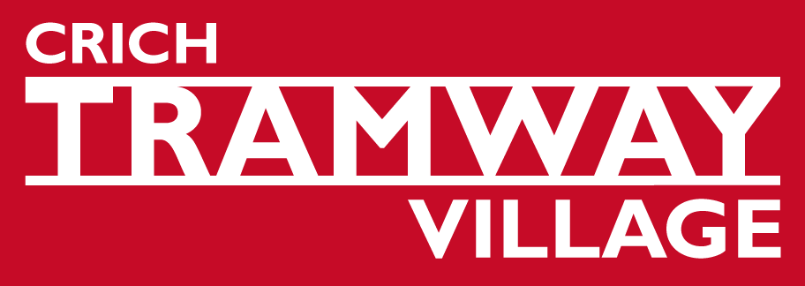

Volunteer Enquiry Form

Thank you for your interest in volunteering at Crich Tramway Village, home of the National Tramway Museum.

What would I do?
We have opportunities for volunteers in most areas of the Museum although there may be a wait for some roles. Whether you would like to work behind the scenes or in the public eye, we have something to offer.

Do I need to know lots about Trams and Tramways?
You don’t need to have any knowledge about trams or tramways to volunteer. Whatever your volunteering role, you will be given full training.

What’s in it for the Museum?
Volunteers are our lifeblood. We currently have approximately 250 working volunteers and 25 full time staff. They assist with the collections, by demonstrating the trams as drivers and conductors or assisting the curator with the archive; organise our special events; act as guides; help with tram restoration and general maintenance and upkeep of the site; assist in our catering and retail departments; help with school visits and holiday workshops.

What’s in it for me?
People volunteer for many reasons, and the Museum can offer opportunities to:

- Meet people | - Share and pass on skills
- Gain experience | - Provide a challenge
- Learn, develop or improve skills | - Spend spare time usefully
- Build confidence | - Improve quality of life
- Add to CV | - Gain a reference

This list is by no means exhaustive and we are sure we can find you a fulfilling volunteer role.

Please return your completed application form by e mail to volunteering@tramway.co.uk or by post to Jan Barratt, Crich Tramway Village, Crich, Matlock, Derbyshire, DE4 5DP

Thank you for your interest.

Name……………………………………………………………………………………………………

Address………………………………………………………………………………………………..…

……………………………………………………………….…Post Code…..………………………..

Telephone (day)……………………………………. (evening)……………….……………………..

Mobile………………………………….

E-mail ……………………………………………………………………………………………………

Which age group are you in?

12-20 ◻ 41-50 ◻ over 70 ◻
21-30 ◻ 51-60 ◻
31-40 ◻ 61-70 ◻

Please tick the boxes when you could be available to volunteer.

 | Mon | Tue | Wed | Thur | Fri | Sat | Sun
AM
PM

How much time per week would you like to spend at the Museum?

Not specific
1 – 2 hours
2 – 4 hours
4 – 6 hours
6 -8 hours
Up to 10 hours
Over 10 hours
Cannot commit to regular hours

Have you any particular areas of interest or types of activity? (e.g., workshop, events, archive, maintenance, catering, administration, guide, tram conducting, education)

....................................................................................................................................................

Do you have any specific support needs? Please specify…………………………………………

……………………………………………………………………………………………………………

Please give details of any previous experience (paid and/or unpaid) or anything else about yourself that you wish to tell us. (please continue on the back of the form if necessary)

…………………………………………………………………………………………………………....

……………………………………………………………………………………………………………

……………………………………………………………………………………………………………
What would you like to achieve through your volunteering role?

……………………………………………………………………………………………………………

……………………………………………………………………………………………………………

……………………………………………………………………………………………………………

Thank you for completing this form.

Your information will be used to find you a volunteering opportunity that suits your preferences and availability. Please understand that this may take some time and there may not be opportunities immediately available. However someone will contact you within 28 days to talk about volunteering at the museum. We will hold your information confidentially and not send anyone your personal details. Some of our opportunities require a DBS check, this will only be made when you have been accepted for a volunteer role and with your agreement.

I agree to the above use of the data I have provided.

Signed………………………………………………………………….Date……………………..……

For Office Use
Action taken:

By: Date:

